 |  | SPRING/SUMMER 2023
Caregiver Hero Award  By Dyonne Wilhelm  This past November, Elaine’s Hope and the Lutheran Home were awarded the inaugural LSS Caregiver Hero award. This award was created in honor of Marty Schreiber and is awarded to individuals for their dedication for serving older adults and enriching their lives and others though compassion, commitment, collaboration, and loving care. This award is a celebration of all our employees who live our mission every day. Lutheran Social Services President and CEO said about the Lutheran Home, “Their compassion extends beyond the residents to the family members and friends that are closest to them. They embody caring for the caregiver”. We extend our gratitude and appreciation for this honor and dedication to the caregivers amongst us!  What to consider…  As some of you may know, our team advocates reading the book Creating Moments of Joy Along the Alzheimer’s Journey, by Jolene Brackey. She delivers messages of awareness, grief, and joy in ways that are personal yet very relatable. One enlightening aspect of the journey we are on is understanding what individuals who have Alzheimer’s can teach us. They teach US to be present. We cannot dwell on the past or worry about the future. A person with Alzheimer’s isn’t capable of hiding, twisting, or changing their emotions like we are. When they are sad, they are sad. When they are happy, they are happy. We should see them with authentic emotions. The residents need us to live in the moment. They need connections.  While we work on staying connected with those we love, we should expect to feel many emotions…joy, kindness, compassion, anger, guilt, fear. In doing so, it is still important to create memorable moments with your loved one. Those moments can be holding hands, sitting outside enjoying the breeze, bringing in a delicious doughnut or ice cream, singing a song together, kissing them on the forehead, rubbing lotion on their hands, talking about your favorite vacation, combing their hair, bringing in a hot ham and roll sandwich on Sunday, letting them wear their favorite outfit two days in a row, sharing a funny story, or reading the mail.  Laughing, smiling, and a gentle touch or hug can go a long way. When words are hard to grasp and understand, a smile and a pat on the back can be more meaningful and impactful for individuals with dementia. It’s a great reminder that we are all human and long for connection in a variety of different ways. Remember, aim for that connection! |  | NewsLETTEr CONTENT
Community Updates
Chaplaincy UPdate
Tips & tricks
Staff Highligt
Elaine’s Hope Moments of Joy
Caregiver SupporT
Upcoming Events

ELAINE’S HOPE
Moments of Joy
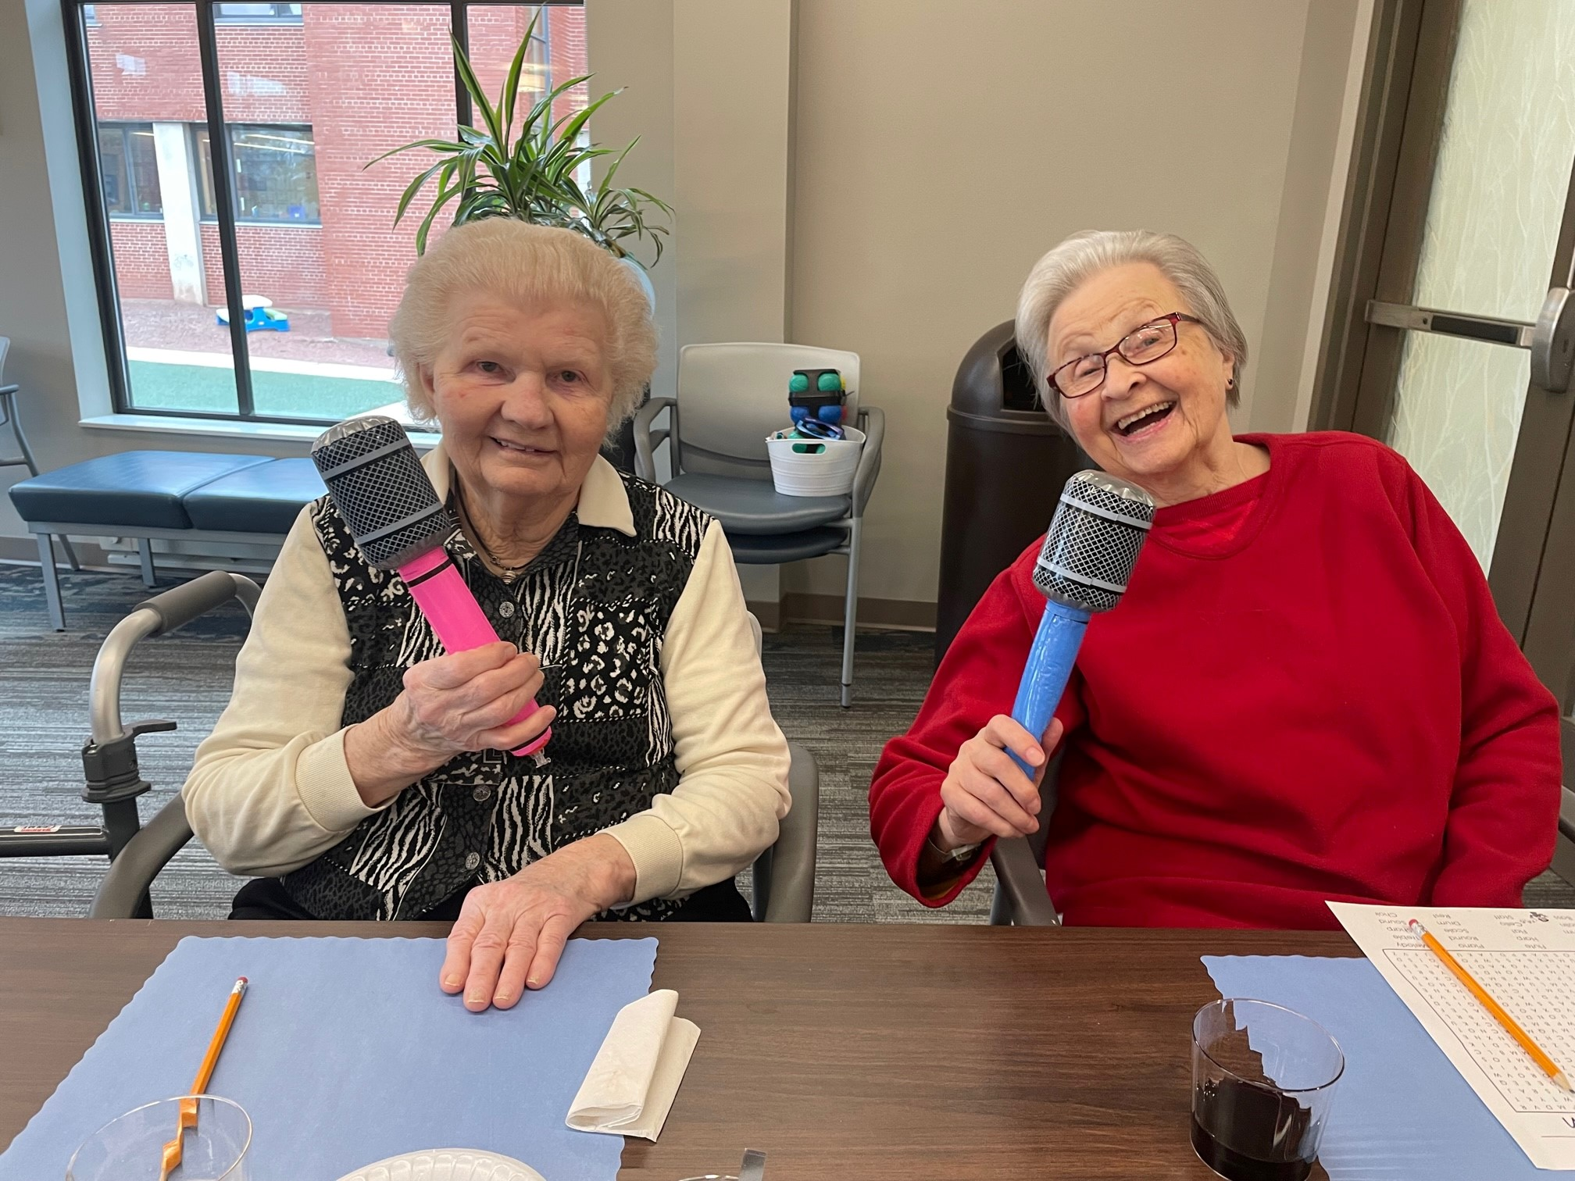
Fun and games
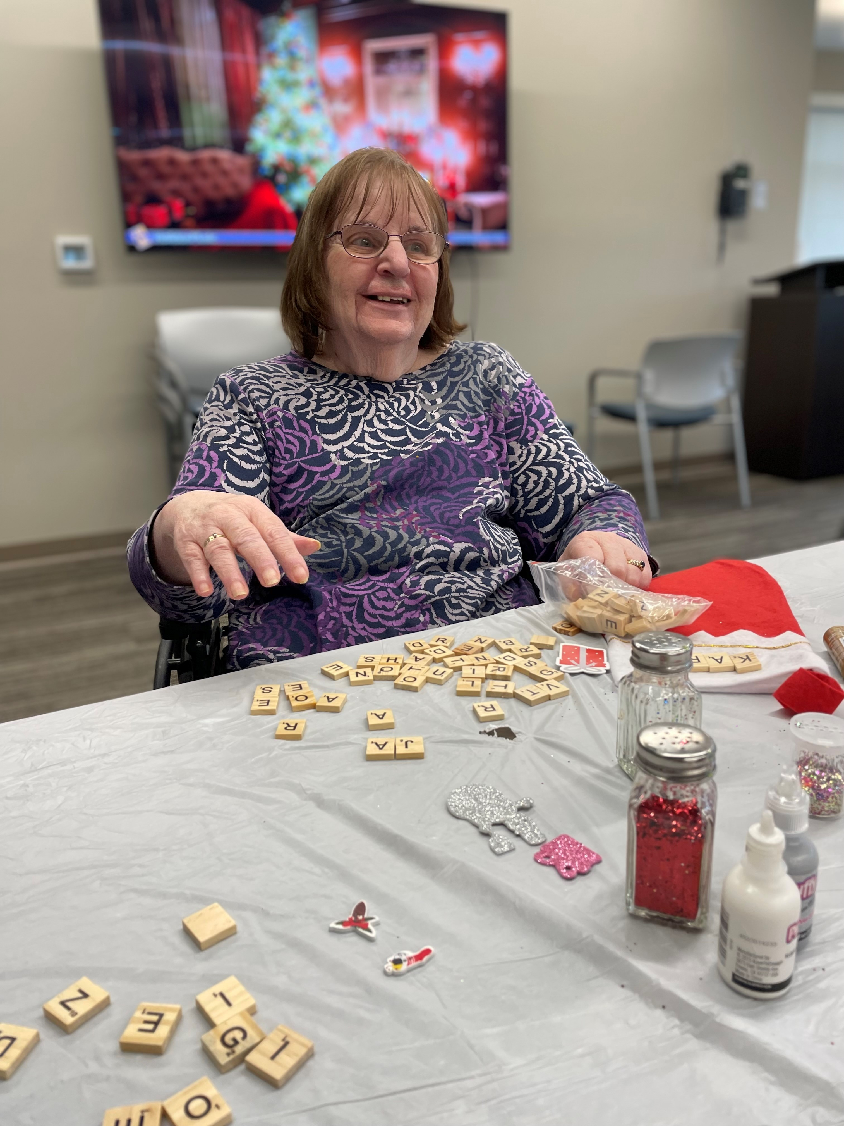
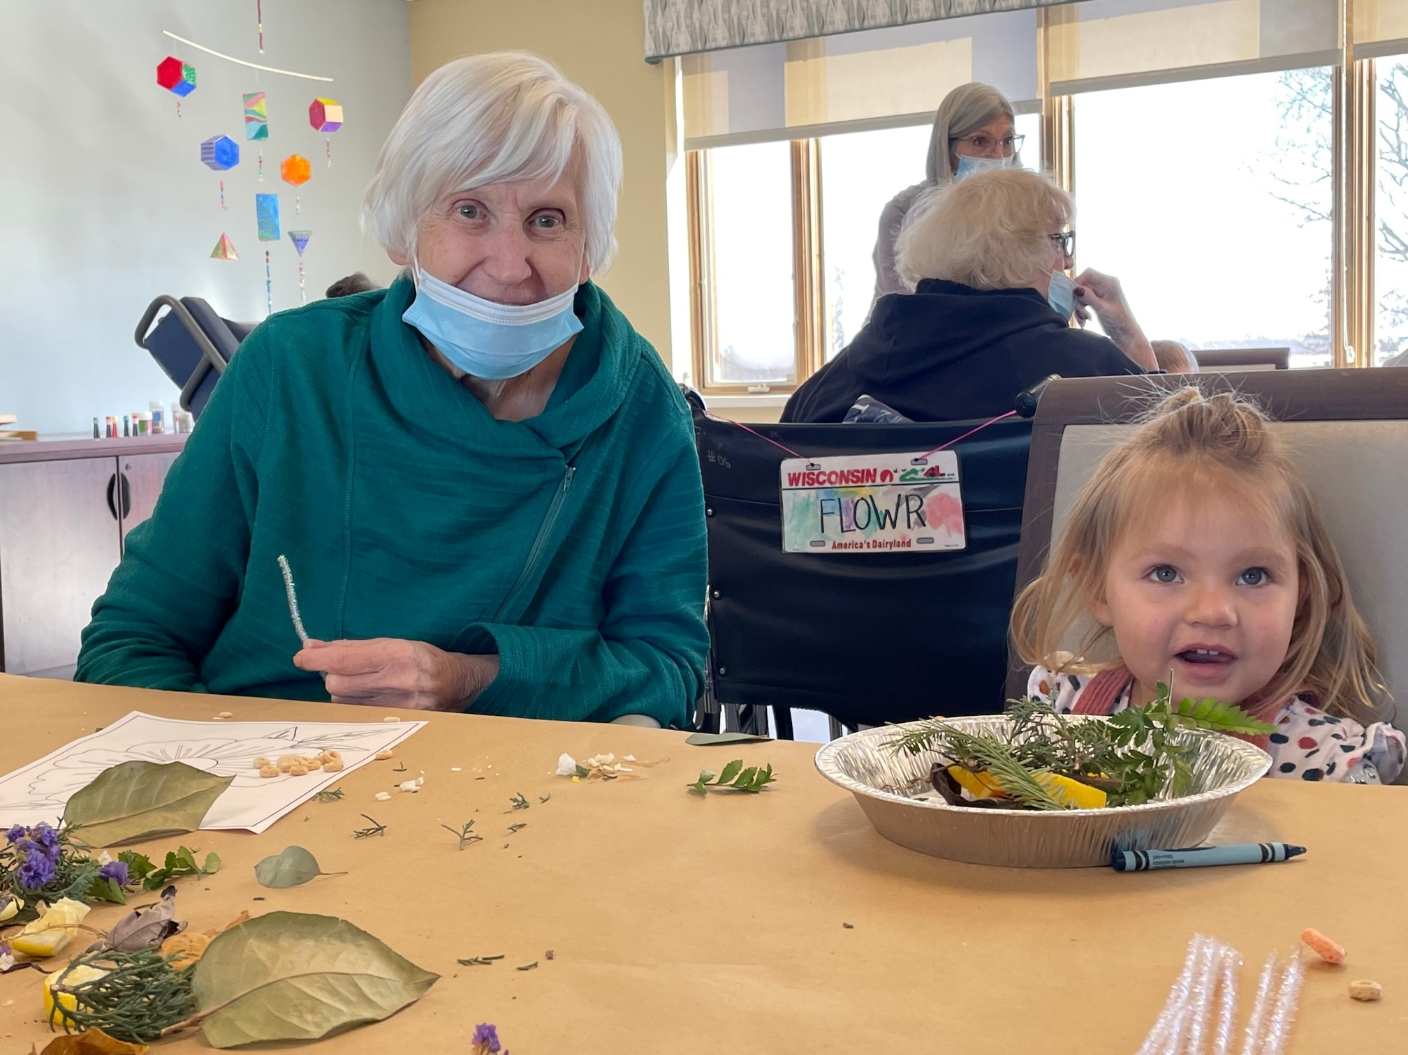
Making suncatchers
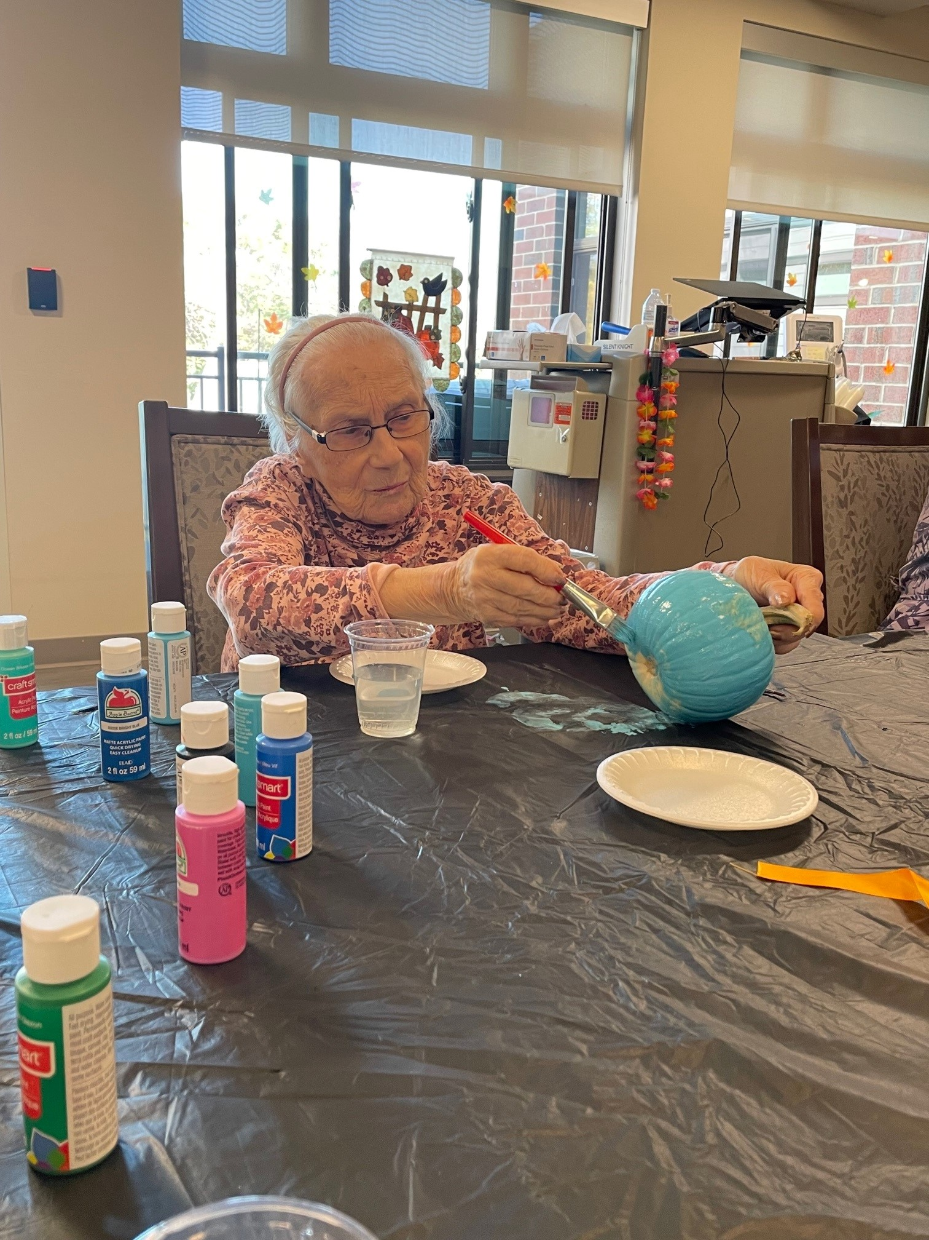

w
From Winter to Spring  By Chaplain Derek  As I write these words today the weather reports warn of a major, multi-day snow event headed our way this week. All I can think of is, “Yuck!” Having lived in Wisconsin most of my life one would think that I would simply give in and accept that the winters can be brutal. Even as a kid I used to think, “just get through February and the worst of it will be over.” After all, spring comes in March, and with it the promise of longer days, more sunshine, warmer temperatures. But before we get to the positive aspects of March we still must get through that last full month of winter. So, when the snow starts to pile up, and the temperatures plummet, and the winds blow the chill right through us, we know that ultimately spring will come. It is a certain truth. It cannot change. Soon the tempest of the winter and its storms will be past. Spring is that promise of a new beginning, having survived the worst we can now enjoy the best of what our region has to offer. It’s such a fitting parallel to the Christian message of forgiveness and renewal. As people of faith, we often experience a “winter” of hardship, uncertainty, fear. The winds of decline blow around us, sometimes causing sadness and fear to pile up like snow in a blizzard of trials. It’s all we can do to hold out for the promise of renewal in Christ. Just as the warmth and rebirth of  spring refreshes us after the winter months, the promise of God’s presence and love among His people renews us with the promise of new life through the actions of Jesus. The words of Psalm 23 ever ring true, “Even though I walk through the valley of the shadow I will fear no evil, for Thou art with me.” The fears and trials that we endure today will be pushed aside and overcome by the promise of mercy, love and restoration that come through the Lord. It is as reliable as the calendar pushing us from winter into spring. And we have the promise that whatever we face, we do so with the Lord’s presence, that we would be directed to look forward to the relief and the new life that He offers in Christ our Lord. May we all find renewal and life in His promise and presence. Amen.  TIPS & TRICKS  ELAINE’S HOPE  Moments of Joy  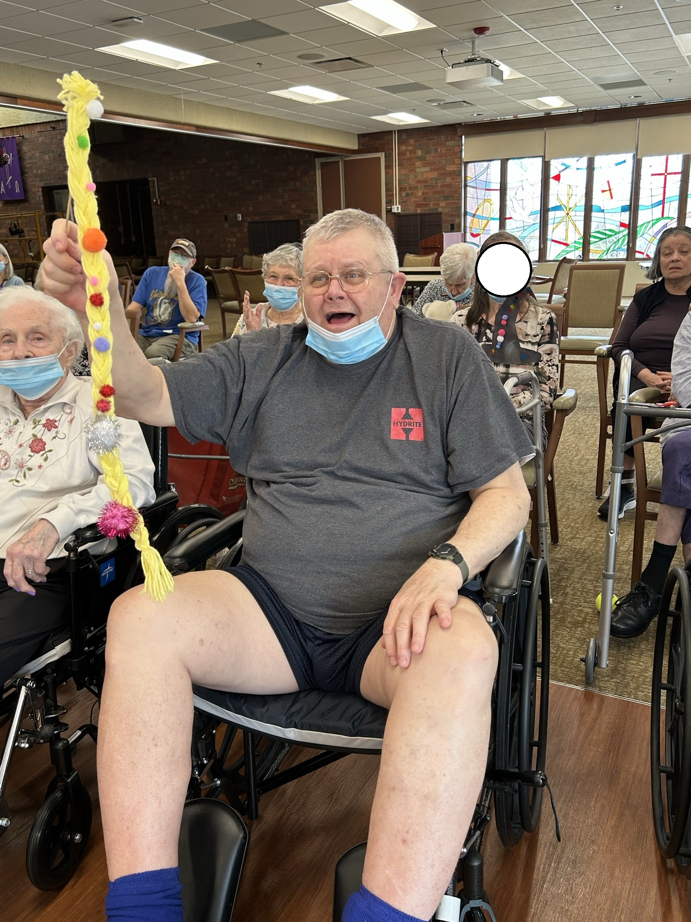  Elaine’s Hope residents enjoyed creating props for a play as part of our Intergenerational programming.  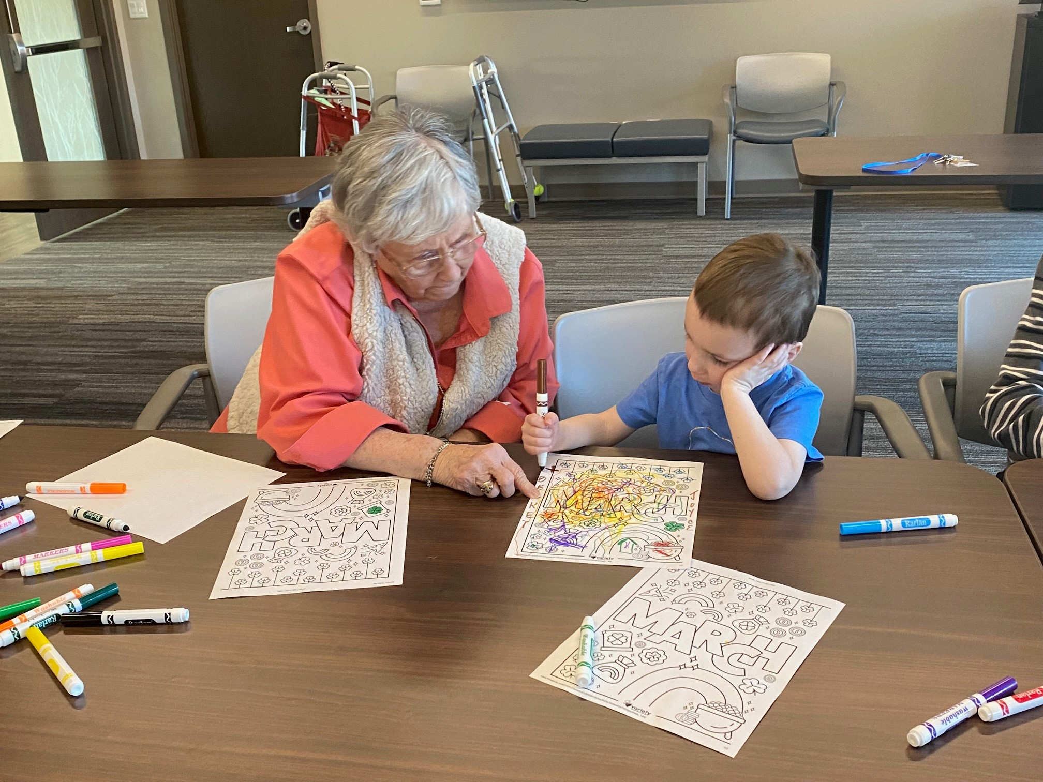  Helping the younger generation color  Irish dancers for St. Patrick’s Day  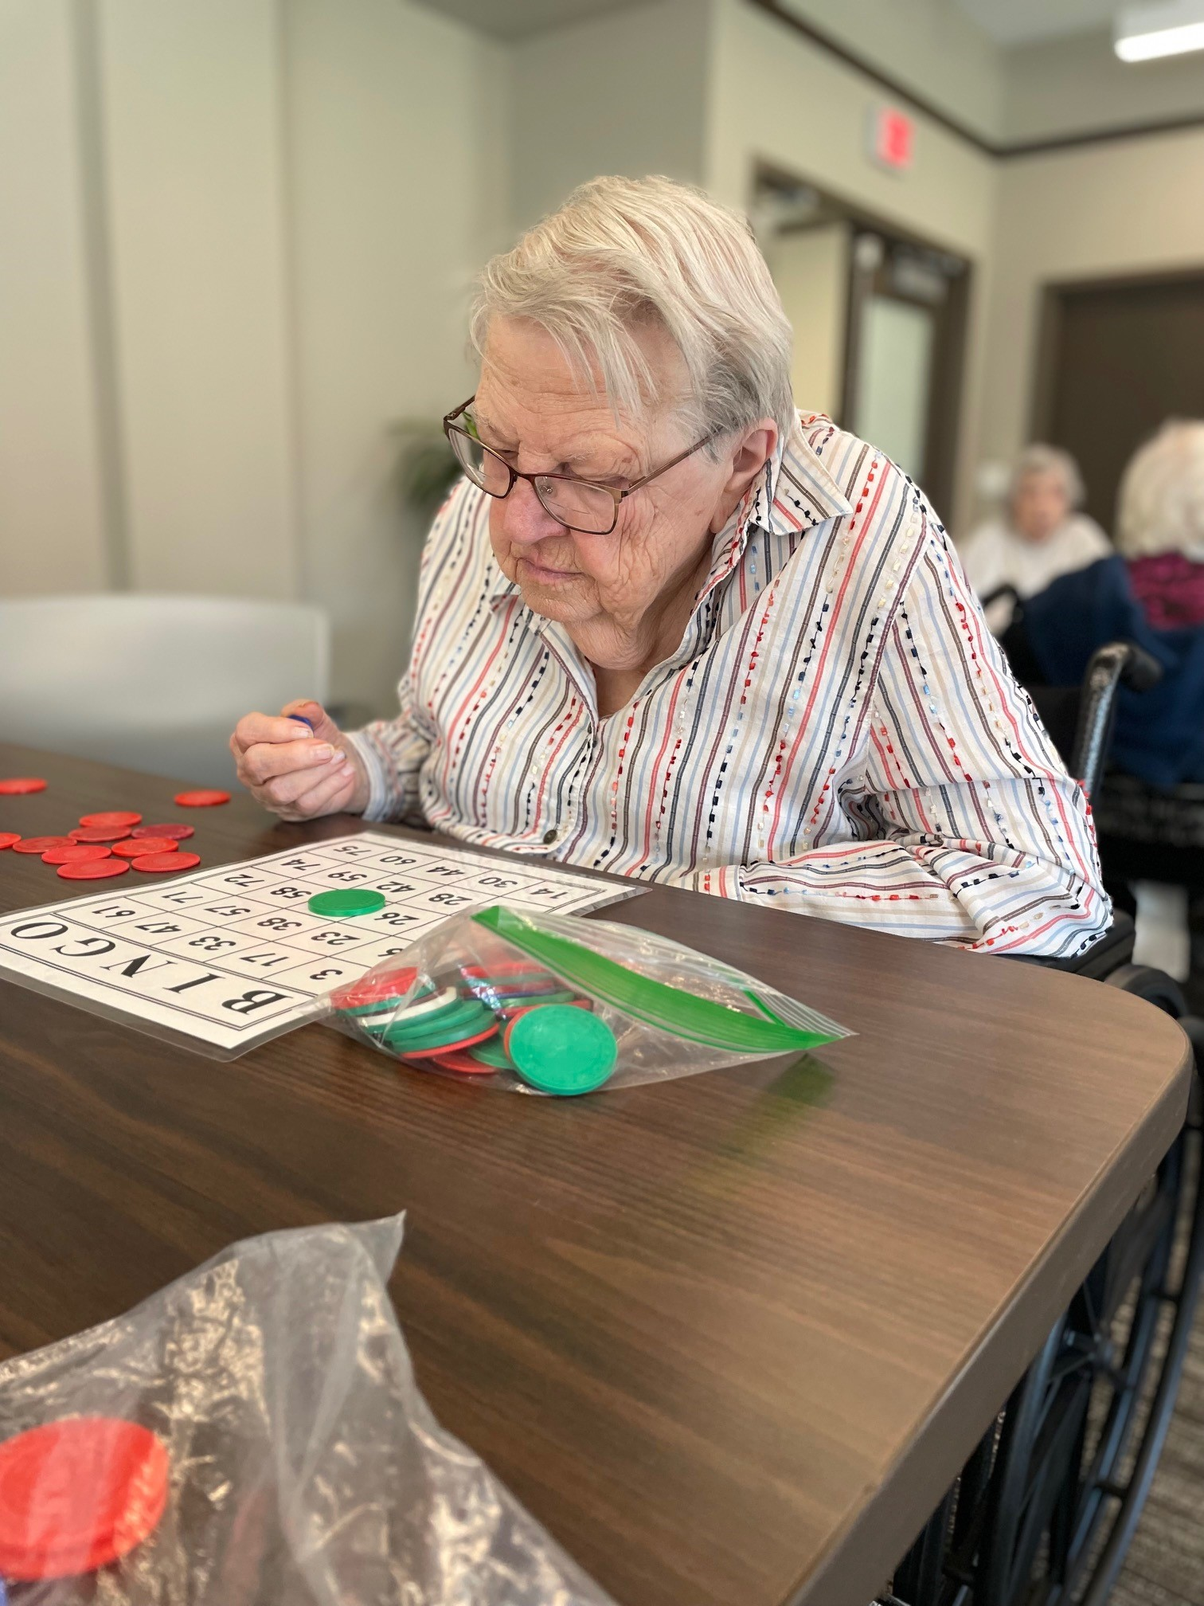  BINGO!  By Rachael Wuensch  Communication may become difficult for your loved one. Here are some tips and tricks for working through communication challenges.  Resist What’s Natural  - Avoid the small talk starters such as, “What’s the matter?” or “What did you do today?”  - Take the time to ask what you are experiencing/seeing. For example, “You seem upset. How can I help you?” or “I heard you spent time with the kids on the playground. I bet it was nice to be outside!”  Avoid Saying ‘No’  - ‘No’ can be limiting or may seem like a punishment.  - Some great alternatives include:  - “Unfortunately, we can’t right now. Maybe next time.”  - “I’m not sure we can do ____ right now, but we could do ____ instead.”  - By avoiding ‘no’ we eliminate the feeling of being punished, lack of being independent, and avoiding the resident being ‘wrong’.  Use Short and Simple Sentences  Short and simple is easier for your loved one to comprehend when communicating. For example, leaving out specifics such as locations or street names will make it easier for your loved one to recall and respond.  - Use a short sentence such as: “John told me he took you out for dinner.”  - Avoid long sentences such as: “John told me he took you out for dinner on Tuesday for pizza on the south side near our old church on 1st street.”  Leave Time for a Response  - As we get older, it takes more time to recall and respond. With dementia, individuals need extra time to process, explain, or find the right word to articulate themselves.  - It is important to give your loved one time to comprehend and time to give a response.  - If you find yourself trying to fill the silence while they are thinking, try the following tips:  - Practice deep breathing  - Breathe in and hold for three counts, exhale for three counts  ELAINE’S HOPE  Moments of Joy  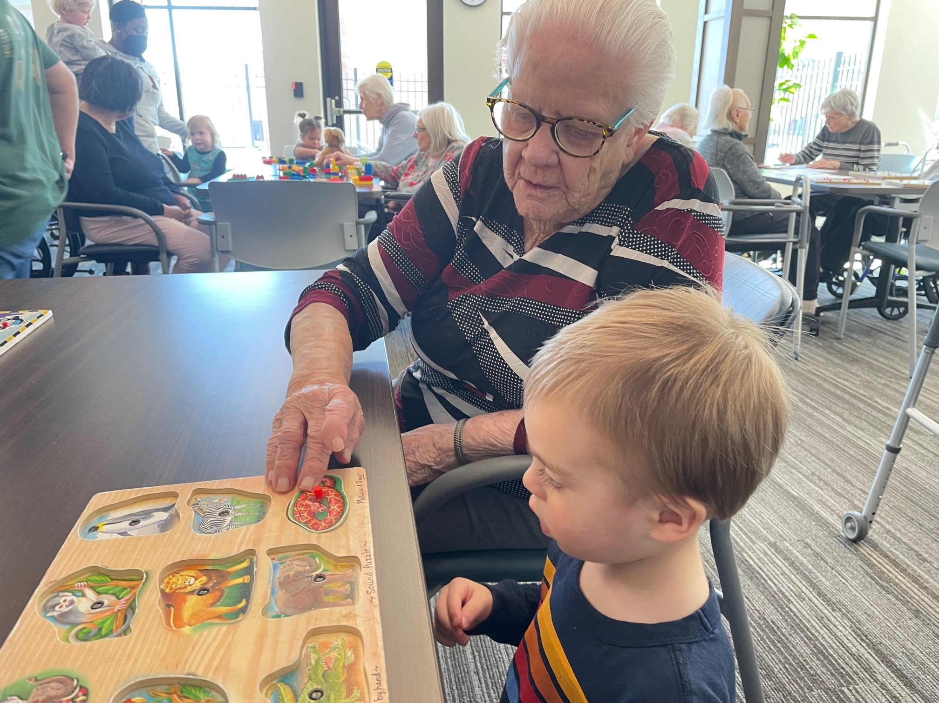  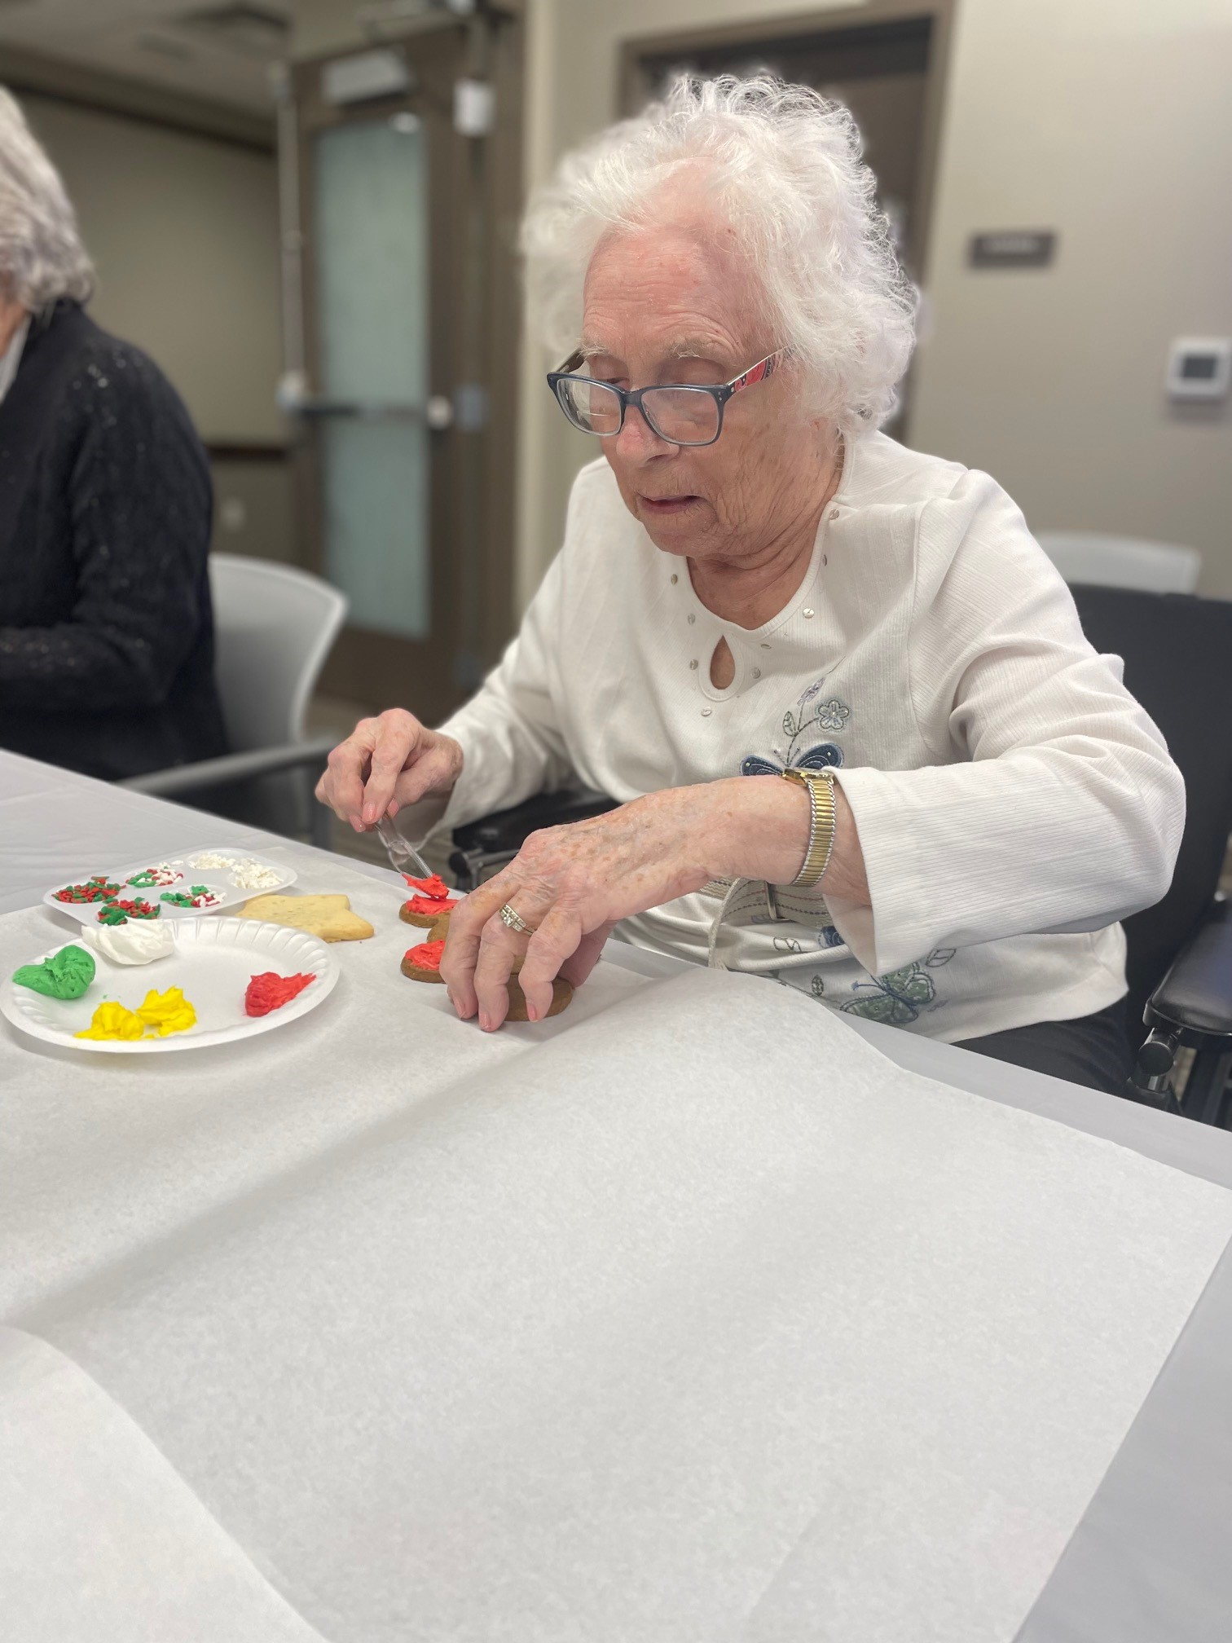  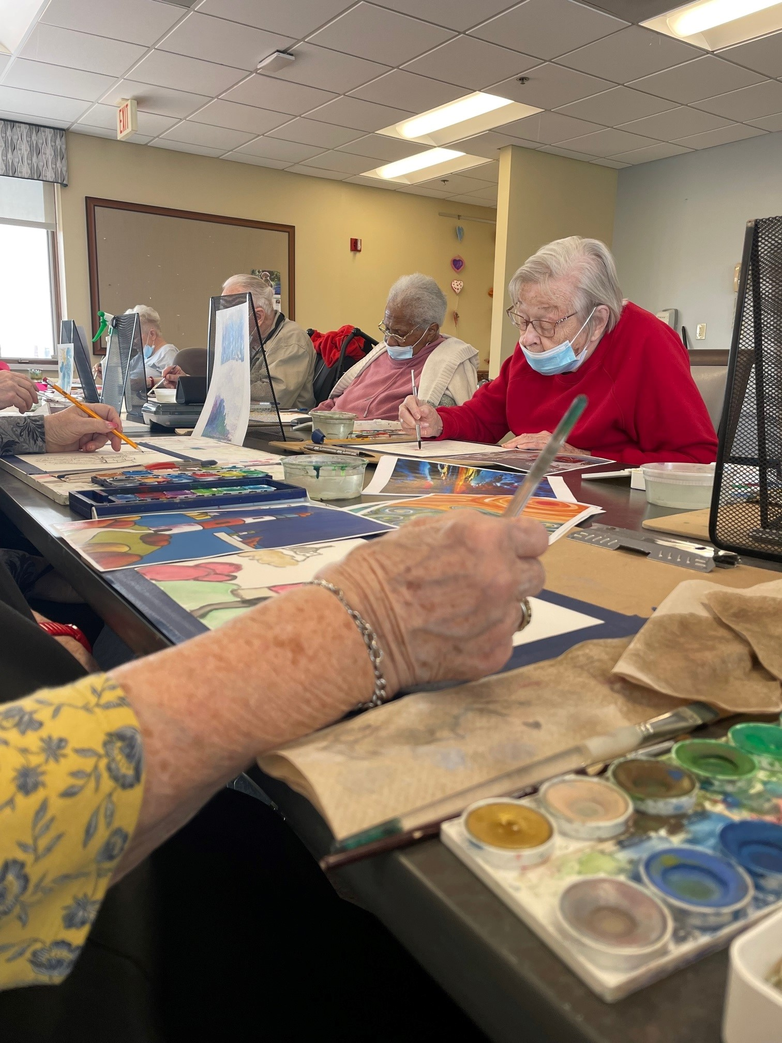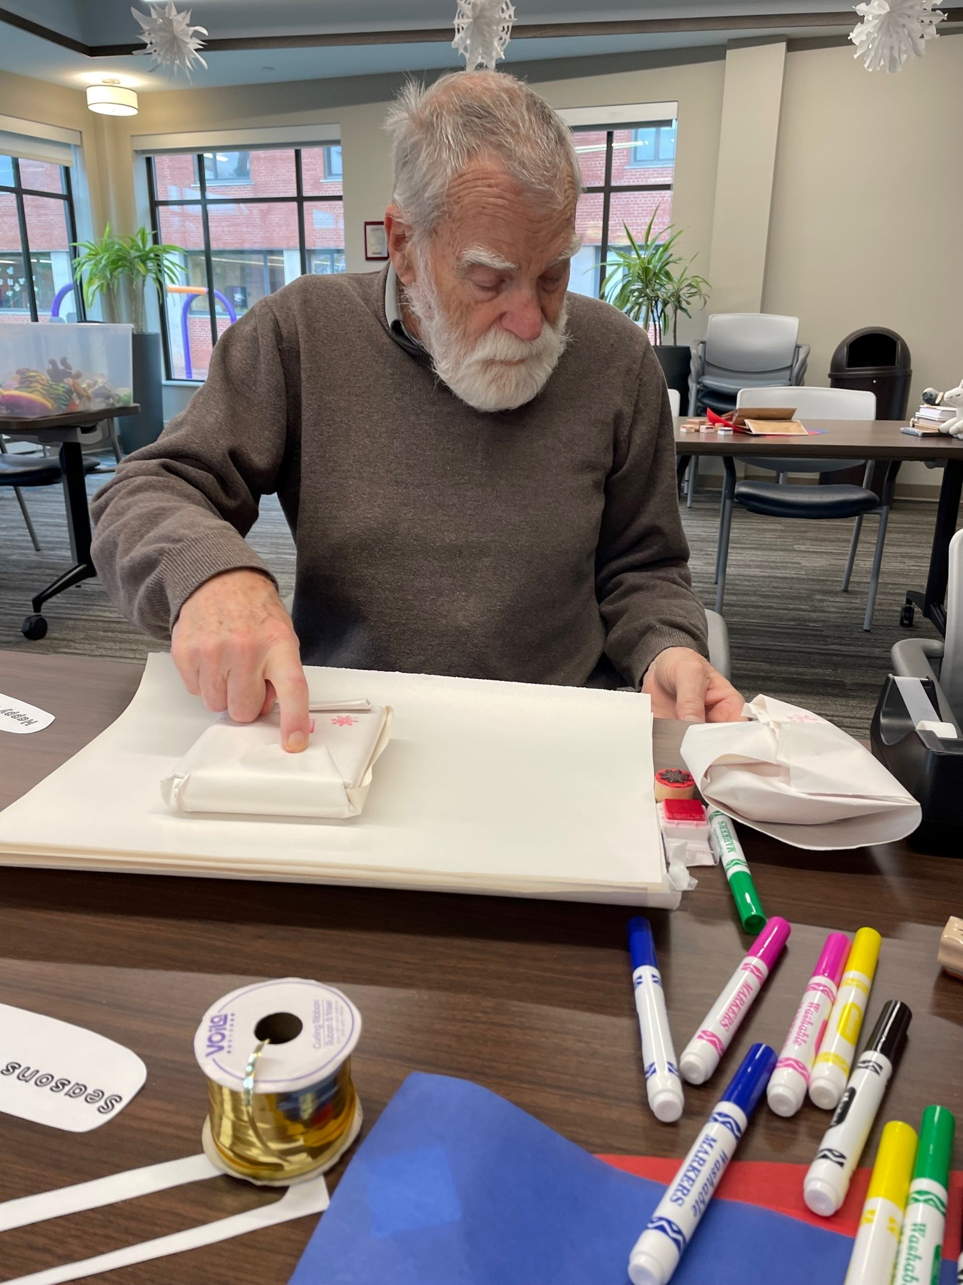  - Count to 5 slowly  - Focus on your feet.  - Actively think about your feet touching the floor or try wiggling your toes in your shoes.  Fill The Gap  When your loved one is having a hard time searching for the right word or memory, try to help find the word they are searching for.  - It can be helpful to use the following phrases:  - “I may be off, but were you referring to ____?”  - “Oh shoot! I can’t recall… is it possibly ____?”  - “Hmmm, are you talking about ____?”  - When in doubt and or if you recognize that the individual is becoming frustrated or agitated, reassure them it’s okay. Examples of this could include:  - “Don’t sweat it mom, I hear what you’re saying.”  - This example validates that you grasp the general idea of what she’s trying to relay. Details aren’t important!  - “No worries, it will come to us sooner or later. We’ve got time.”  - This example shows that answers are not always important. Spending time with your loved one is what matters most.  Rephrase  - Repeat what your loved one said. When repeating your loved one, it acknowledges that you are listening to what they have to say, even if it does not make sense logically.  - By restating what your loved one says, it may, in return, allow them to elaborate or continue talking about the subject at hand.  Address Behavior or Mood  - As stated earlier, words can be hard to find, therefore feelings can be hard to grasp and communicate.  - Paying attention to body language during conversation can often tell us more than the words we speak.  - If you are noticing your loved is fidgeting or is physically uncomfortable, try saying, “You seem upset.” Or “You look upset and I would like to help you.”  - With these examples, you are helping by noticing how they are feeling and offering assistance during a time that may be difficult to ask for help.  MCAL  ELAINE’S HOPE  Moments of Joy  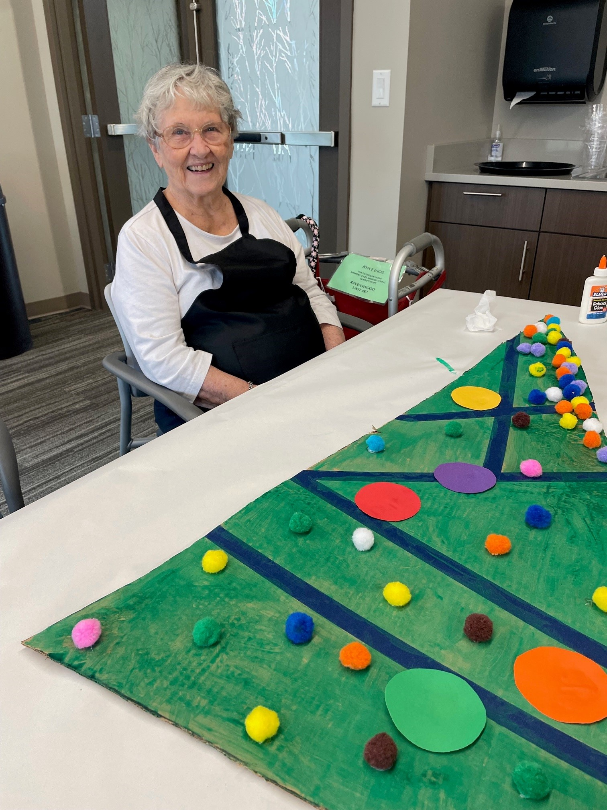  Valentine’s Party fun!  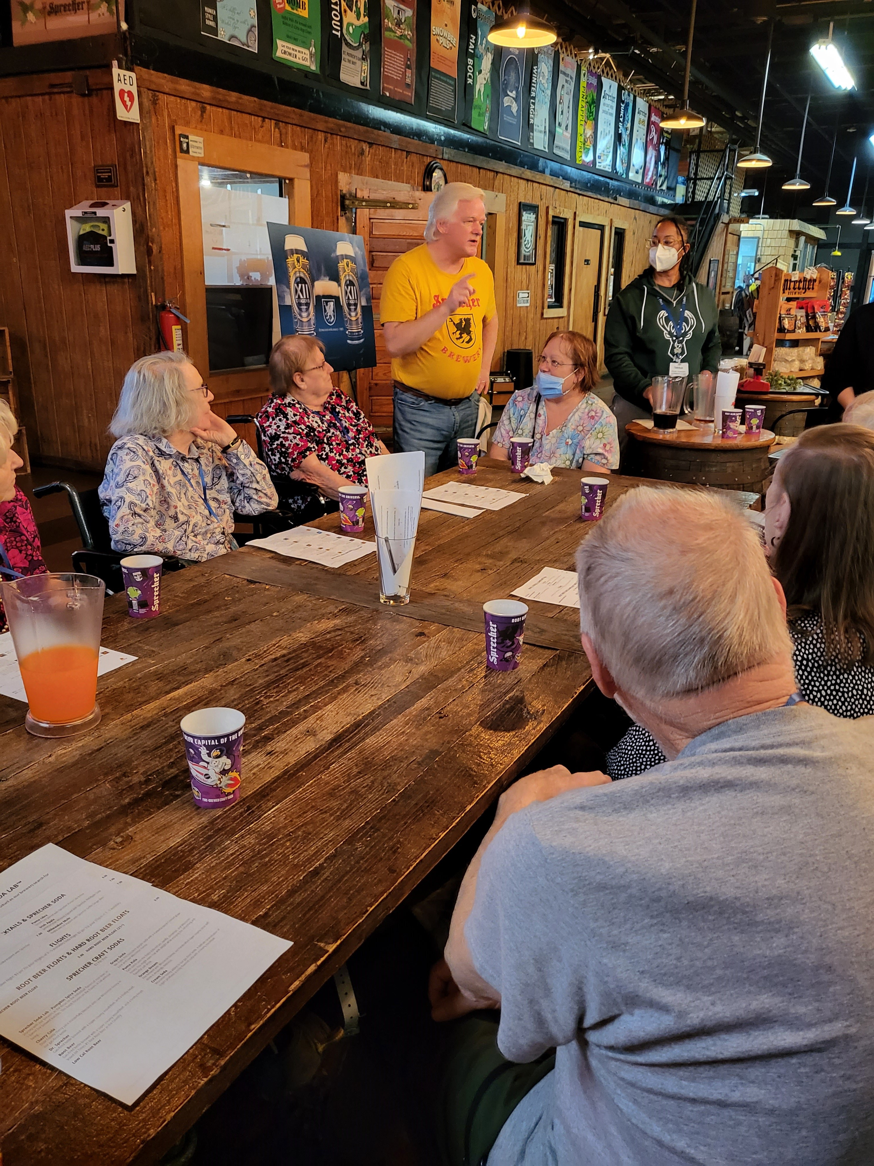  Sprecher Outing  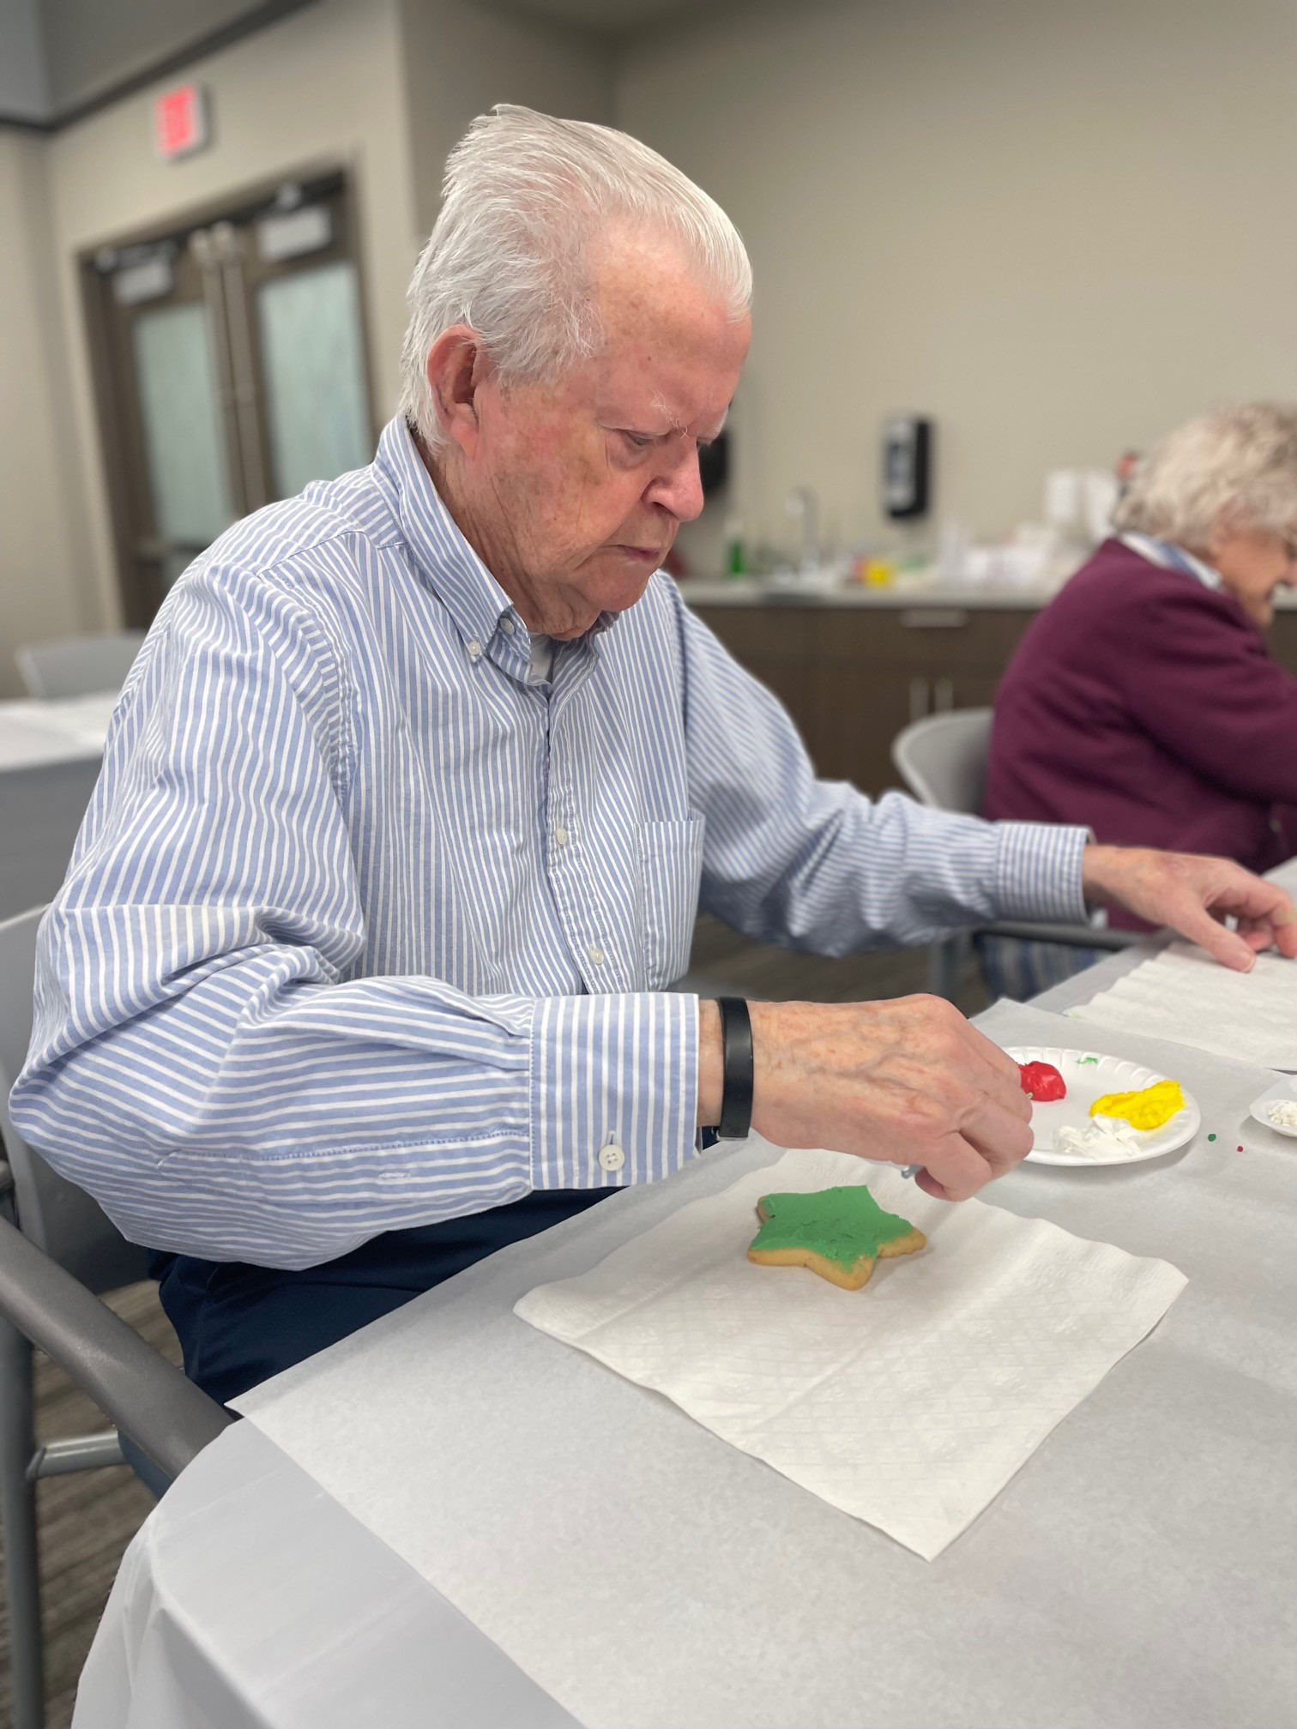  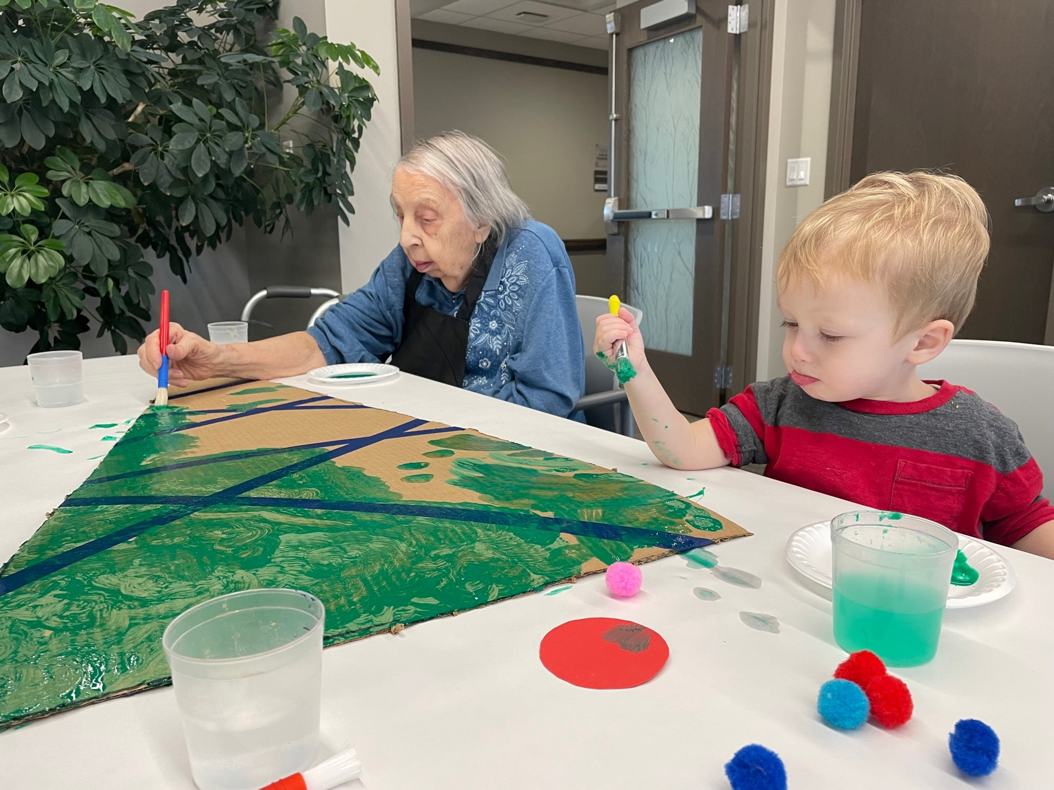  MAY BIRTHDAYS  Betsy H. 3rd  Barb J. 2nd  Ruth P. 6th  Edith “Elinor” H. 7th  Joan P. 13th  Lorraine M. 15th  Rhoda K. 19th  Greg M. 25th  Fern P. 26th  Patrick M. 29th |  | Spiritual Support  Chaplaincy Services  The Lutheran Home and Harwood Place serve people of all faiths with compassionate spiritual care that honors individual preferences within a supportive community. You may contact Chaplain Derek in the Chaplaincy Department at (414) 258-6171 x 349.  Worship Services  Lutheran Home provides a variety of worship opportunities Sunday mornings and during the week. Sunday morning services at the Lutheran Home are simulcast to rooms through the in-house TV network.  Catholic Services  Catholic Mass is the 2nd and 4th Thursdays. Eucharistic ministers come on the opposite weeks.  Spiritual Support Groups  Bible studies, prayer groups, and Rosary groups are available during the week to support mental, physical, and spiritual health.  CHAPLAIN DEREK WOLTER  Phone: (414) 258-6171 x349  Derek.Wolter@thelutheranhome.org

Employee Spotlight Sydney Buck  Care Manager for Elaine’s Hope  Sydney Buck, Elaine Hope’s new Care Manager, is a Wisconsin-born native from the Milwaukee area. Sydney has experience working as a caregiver in several memory care facilities as well as caring for her grandmother with Alzheimer’s disease. This experience inspired her to enter the long-term care industry. In 2021, Sydney graduated from UW-Milwaukee with her bachelor’s in Health Care Administration. Sydney also has experience in hospice care and admissions. She brings both the elements of caregiving and administrative roles to the organization. Sydney is passionate about providing and ensuring quality care. Outside of work, Sydney enjoys spending time with friends and family, being outside in the summer with her 14-year-old cat named Fluff and going to Bucks games! Sydney looks forward to this new opportunity and adventure at Elaine’s Hope. |  |  | Keep in Touch  Elaine’s Hope Neighborhood Phone Extensions  Highlands: x514  Pasadena: x524  Ravenswood: x534  Administrative  Phone Extensions  Administrator  Dyonne Wilhelm x378  Care Manager  Sydney Buck x326  Nurse Manager  Dannie Rombca x727  Program Manager  Rachael Wuensch x230  Director of Caregiver Support  Stephanie Leanes x726  (Office located on SE side of LH)  Urgent Matters ONLY:  Nurse Cell Phone 414-217-0873
Dropping off a new piece of clothing, pillow, hat, jacket, or any other article of clothing?
Just label the bag with your loved ones full name and drop it off at the Elaine’s Hope entrance. Please remember that 100% cotton and wool is discouraged as articles will shrink. It will be labeled and delivered to your loved one!
FREE 2-HOUR  DEMENTIA WORKSHOP  This workshop is specific to family and friend caregivers of someone with dementia.  Topics Include:  - Dementia and the differences  - Early, moderate, late-stage dementia  - Communication and making the most of your visits  - Techniques to interact with someone with dementia  - Caregiver struggles and taking care of yourself  Every attendee will receive the book My Two Elaines by Marty Schreiber.  Register today at thelutheranhome.org/caregiver  Questions? Contact Stephanie Leanes, Director of Caregiver Support, at 414-258-6171 Ext.726 or email Stephanie.Leanes@thelutheranhome.org. |  |  | Upcoming Workshops  Thursday, April 20th  5:30pm-7:30pm  (Elaine’s Hope)  Saturday, May 20th  10:00am-12:00pm  (Elaine’s Hope)  Tuesday, June 20th  5:30-7:30pm  (Elaine’s Hope)
Caring for someone with Alzheimer’s disease can be lonely and overwhelming. To help, the Alzheimer’s Association created ALZConnected, the first dedicated online social networking community where people with Alzheimer’s, their caregivers and others affected by the disease can share answers, opinions, ideas and support. Go to ALZConnected.org and check it out.
Get support day or night from the Alzheimer’s Association No question is too big or too small. Call our 24/7 Helpline (800.272.3900) for free, around the-clock help and the latest information.

Community Updates
Patios Are Now Open
Ask staff to assist with access or utilize your key fob to enter and exit. Please remember to keep the area clean for other residents and families who visit.
Outdoor Gardens Coming Soon
Please reach out Rachael if interested in donating tools or gardening items to help maintain our raised flower beds this spring season. Rachael.wuensch@thelutheranhome.org
414-258-6171 ext. 230
Need for Nail Polish
Residents are asking for more color variety for manicures! If interested, please donate NEW bottles of nail polish. Deliver items to Rachael or Sydney.
Provide Containers for Snacks
When bringing in home baked goodies or snacks, please store treats in sealable Tupperware or Ziplock baggies to keep bugs and pests away. Thank you!
Rotate Clothing
Now that winter has come to a close, please take the time to rotate your loved one’s clothing. Unfortunately, closets are not large enough to have both at one time. This can be a fun activity to do during a visit!
Pack Winter Jackets
During your next visit, please take your loved one’s jacket home for the summer.
Shoe Reminder
Although it’s nice to let our toes breathe in the spring and summer, please remember that it is safest to wear shoes with heels and closed toes! If you have questions, please talk to the Elaine’s Hope team.
ELAINE’S HOPE
Moments of Joy

Red Hats Coffee Corner
